Steps to check health on ECP clusters.

# Dashboard Health check of all services - After logging in to the UI

1. Navigate to Kubernetes -> Dashboard -> Service Status -> check through all the nodes and services to ensure they are all healthy (Green)
   1. Incase any of the services are green, follow the runbooks available [here](https://hpe.sharepoint.com/:f:/s/CaaSDocs/EhKHpHDQ7HNAjFFpJJZmX98B7ydviQ5Y8N0x1kkE3WcPsg?e=jVpu15).

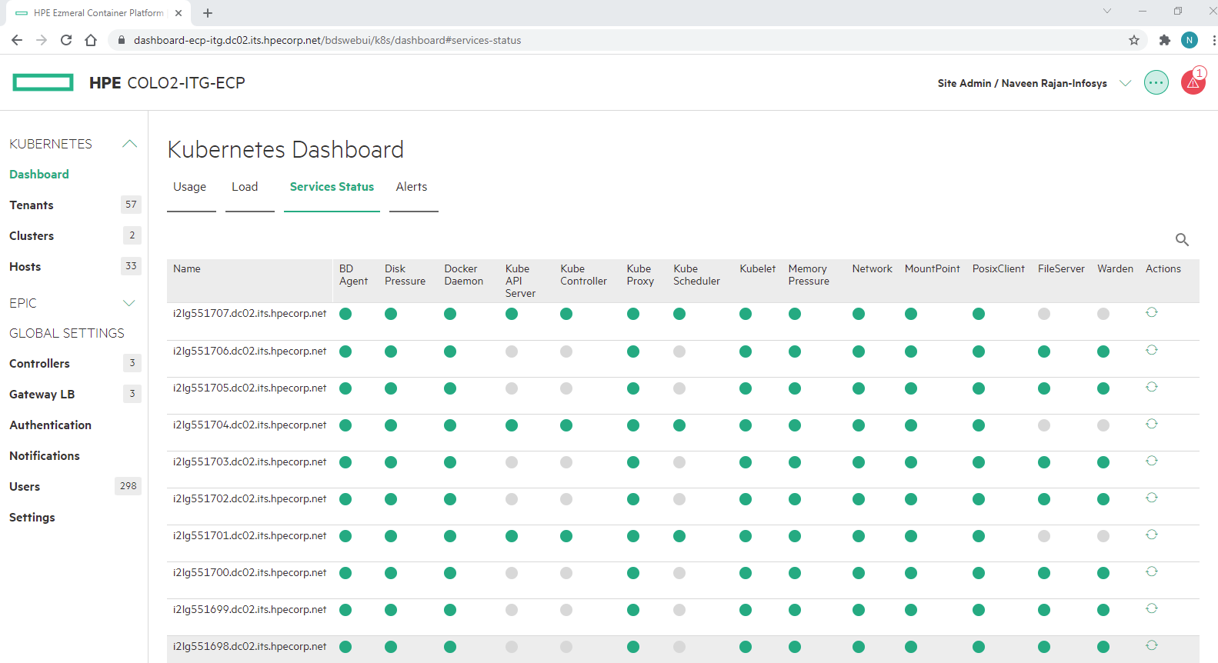

1. Navigate to EPIC -> Dashboard -> Services and repeat step (1)

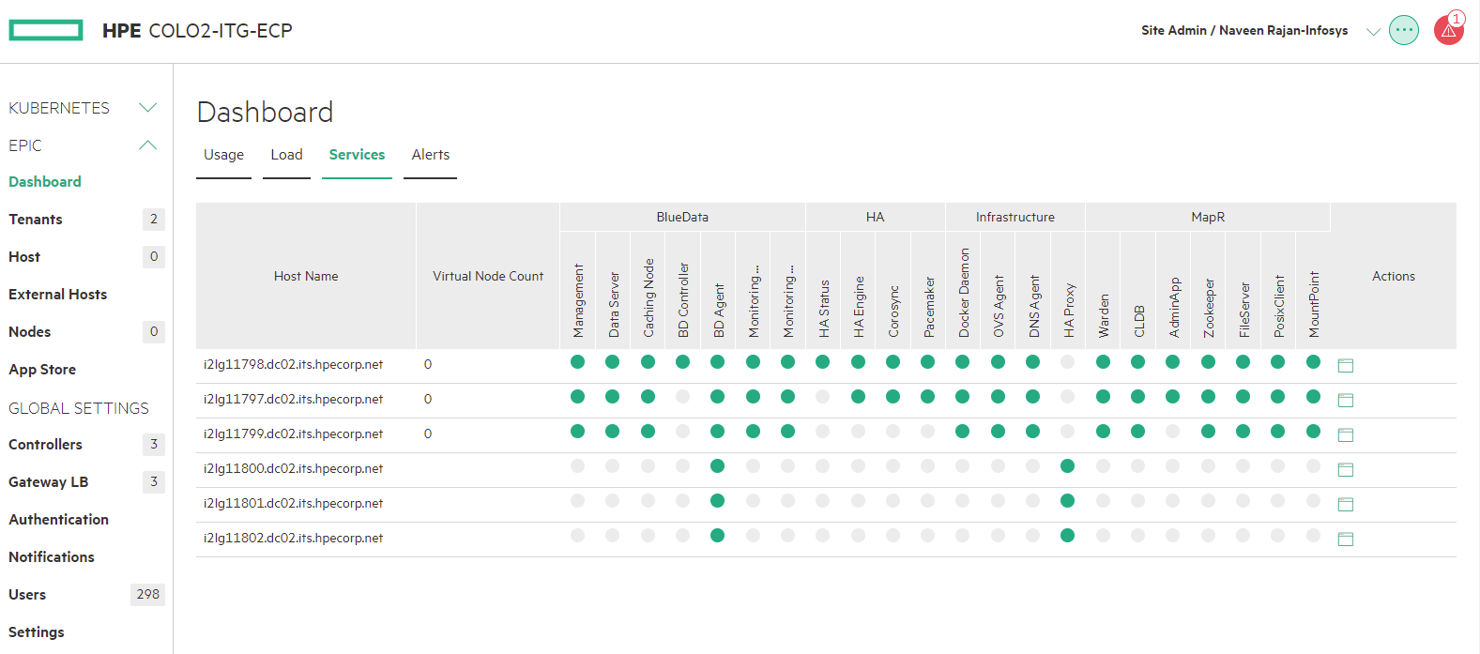

1. Kubernetes -> Hosts and ensure everything is in configured state.

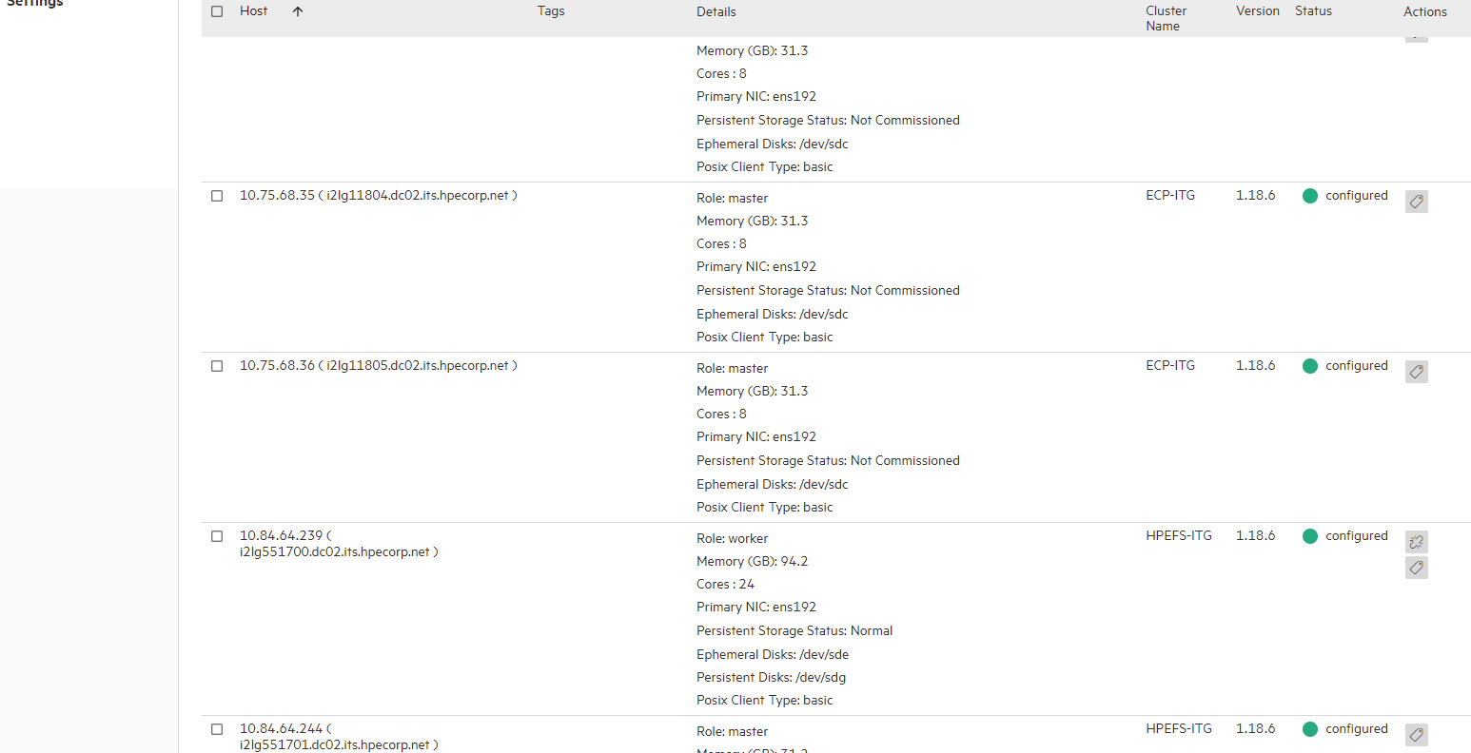

1. Similar to step (3) check controller health status under Controllers section and Gateway nodes health under Gateway section

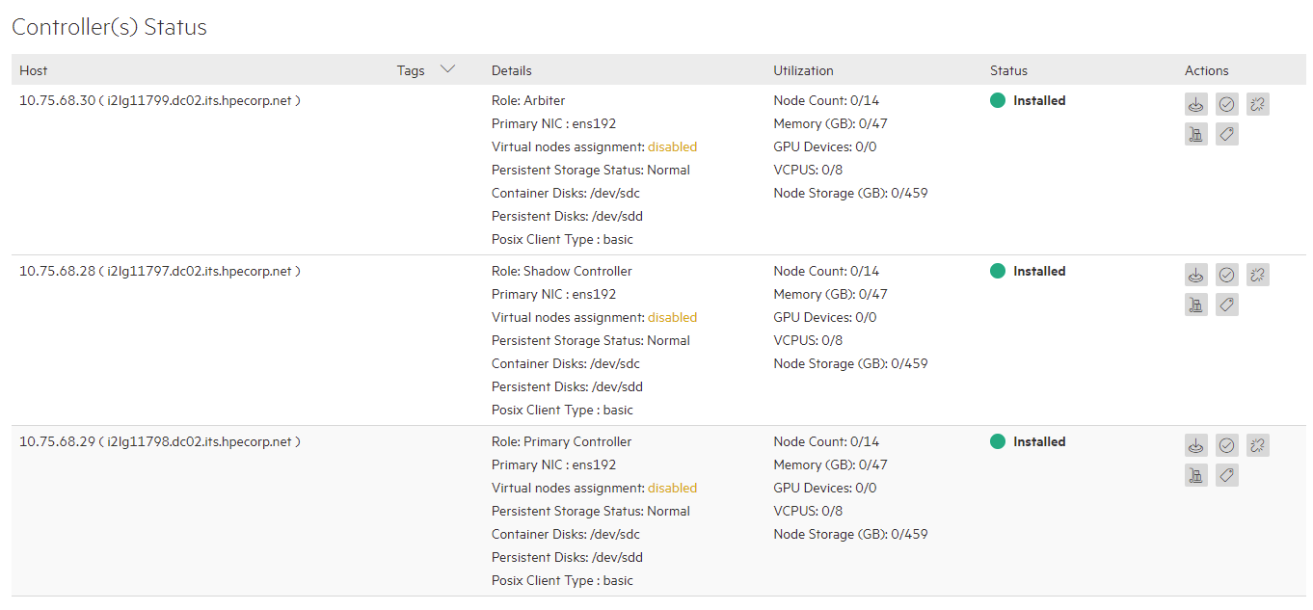

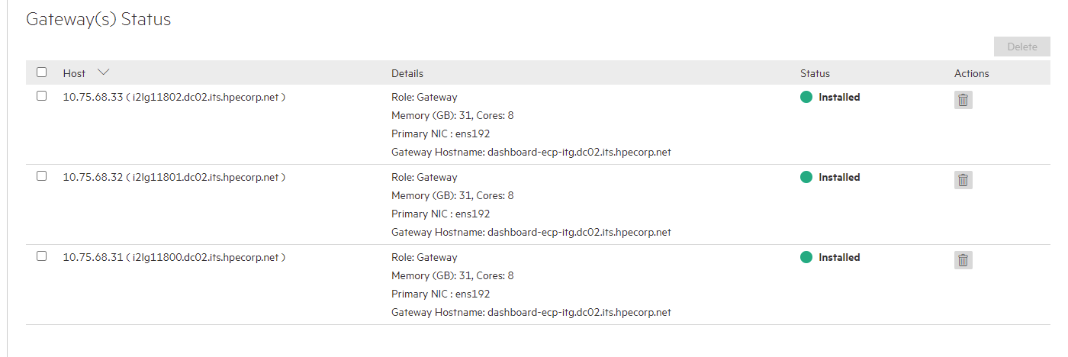

# Health check from Lens (CLI can be used if preferred)

Lens [Wiki](https://github.hpe.com/CaaSonHPE/Wiki/wiki/HPE-IT-Ezmeral-Container-Platform#lens-as-kubernetes-ide-for-hpe-ecp) for new users

1. Check for the Pods count from Lens Cluster page
   1. For example, below snap shows 891 pods, at this time we had 13 workers which gives room for 110 X 13 = 1130 pods i.e., 79 %. Please alarm team is the pod availability percent is lesser than 20.

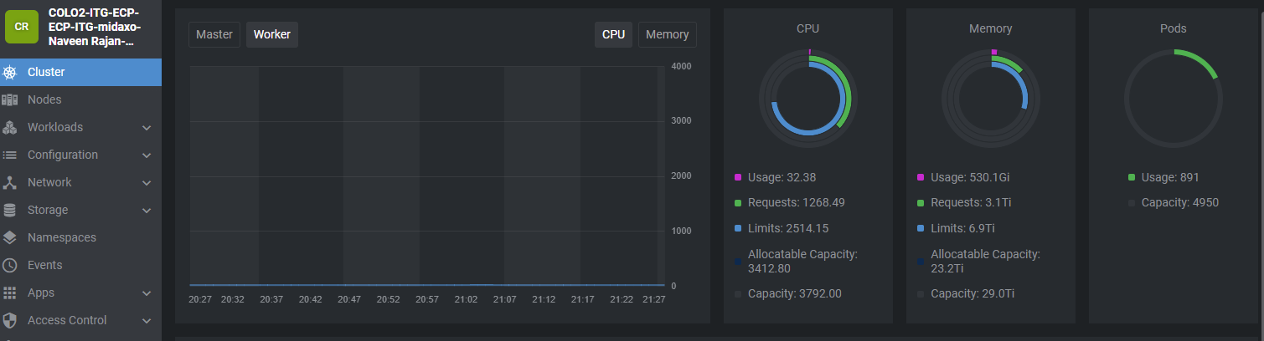

1. Check the number of workers from Nodes section

